Ref: PoSL/OCW/2/001
From: Clerk of Parliament
To: The Chief Immigration Officer
Date: 30th June, 2022.

Dear Sir,
REQUEST FOR THE ISSUANCE OF LANDING VISA/PERMIT

I write to request for the issuance of landing visa/permit in respect of the undermentioned foreign national who will be travelling into Sierra Leone on an official assignment to coordinate Filming of Educational Sites to Construct A Peace College in Sierra Leone, Special Anti-Epidemic Documentary Showcasing President Xi Jinping the Epidemic Leader of the People’s Republic of China.

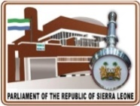
- Mr. Xing. Zhen; Passport No: ED4495607

The aforementioned official is expected to arrive at the Lungi International Airport on the 16th July, 2022.
The Government Whip of the Parliament of Sierra Leone is requesting your office to accord the official the required support towards travelling to Sierra Leone.

Yours Faithfully,
Mohamed Lebbie

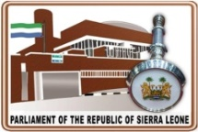

For: Clerk of Parliament

26th July, 2022

From: Clerk of Parliament
To: Director General, Mini. Of Foreign Affairs and International Cooperation

REQUEST FOR RENEWAL OF SERVICE PASSPORT IN FAVOUR OF JOSEPH CONTEH -
ICT DIRECTOR

I write to request for the renewal of service passport in respect the above parliamentary official in the House of Parliament.

Parliament had appointed Mr. Joseph Conteh to participate in an official program schedule to take place in Namibia by the first week of August, 2022.

Parliament is requesting the renewal of service passport to the above named official to enable him to participate as he will represent the Parliament of Sierra Leone.

Attached is the invitation from the organizer.

Hon. Paran Umar Tarawally
Clerk of Parliament

