UNDERSTANDING PARLIAMENT
IMPORTANT FACTS AND PROCESSES YOU NEED TO KNOW ABOUT
PARLIAMENT OF SIERRA LEONE

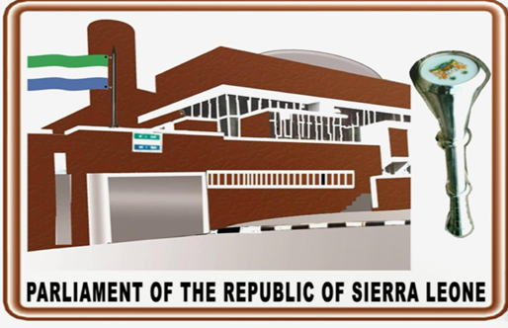

CONTENTS | PAGE NO
Front Cover | 1
Content | 2
Overview | 4
Mandate, Vision, Mission and Core Values | 4
Mandate | 4
Vision | 4
Mission | 4
Core Values | 5
History of Parliament | 5
The Al-Aqsa of Africa | 11
Parliament Election Chronicles since 1973-2018 | 16
First Parliament of the First Republic of Sierra Leone | 16
Second Parliament of the First Republic of Sierra Leone | 17
Third Parliament of the First Republic of Sierra Leone | 17
Fourth Parliament of the First Republic of Sierra Leone | 18
First Parliament of the Second Republic of Sierra Leone | 18
Second Parliament of the Second Republic | 19
Third Parliament of the Second Republic | 20
Fourth Parliament of the Second Republic | 21
Fifth Parliament of the Second Republic | 21
Educational and Innings Analysis | 22
Age Profile | 22
Innings | 22
Educational Level Attained | 22
Procedure in the Chamber of Parliament | 23
Summary on How a Bill Becomes Law | 24
Sessional Statistics of the Fourth Parliament | 27
How Parliament Committee System Works | 28
The Parliamentary Committee Systems | 28
Establishment of Parliamentary Committees | 28
Powers of the Oversight Committees | 29
List of the Committees in Parliament | 29
Procedures for the First Sitting of Parliament | 31
Main Activities | 31
Chamber Procedure on the First Sitting | 31
Procedure for the Speakership Election | 31
Election Process | 32
Nomination Process | 32
The Budget Process | 33
Introduction | 33
Budget Preparation | 34
Budget Approval/Legislative Process | 34
Budget Implementation | 35
Sub Appropriation Procedures and its Financial Provisions | 35
The Financial Provisions | 35
Presentation, first Reading and Second Reading of Appropriation Bill | 35
Committee of Supply | 36
Allotment of time in Committee of Supply | 36
Procedure in Committee of Supply | 36
Amendments to Heads of Estimates in Committee of Supply | 37
Third reading of Appropriation Bill | 38
Supplementary Appropriation Bills | 38
Back Page | 39

Overview
Parliament of Sierra Leone is the legislative arm of Government that makes provision for elected Members to represent the voices of their electorates, to make Laws, ratify treatises and policies, budget allocation and oversight scrutiny for the wellbeing of the people of Sierra Leone as stipulated in Section 73 subsection 1-3 and Part VI respectively from the 1991 Constitution of Sierra Leone.
Members of Parliament (MP’s) comprises of directly and indirectly elected representatives who meet to debate, amend and pass laws for the good governance of the country,
The Fifth Parliament of the Second Republic has a composition of 146 Members.

Each of the country’s fourteen districts is represented by Paramount chiefs from these 14 administrative districts whilst 132 members are directly elected concurrently in the presidential elections.

The administration of the Parliament of Sierra Leone is headed by the Clerk of Parliament, assisted by a Deputy Clerk and 10 heads of department that are responsible to provide technical and administrative support and advisory services to enable Members of Parliament effectively and efficiently execute their constitutional mandate (Parliamentary Service Act, 2007. Part II, Section 3).
The total staff strength as at June, 2019 is 318 including contract workers of the Parliamentary Service; fulltime staff is: 125 and Contracts: 8.
Parliamentary Service staffing management is subdivided into three categories:
Senior Level Management: 17 Members
Middle Level Management: 46 Members and
Supporting/Junior Staff: 70 Members
Parliament has two buildings which are used by MPs and staff for parliamentary functions and activities. The main building has the Chamber; where the Speaker and Members meet to transact the business of the House by deliberations. It also hosts offices for the Parliamentary Service Commission and Parliament Leadership.
The Administrative building has offices that are occupied by a variety of functionaries, including Chairmen, Deputy Chairmen of Committees, Consultants, Directors and Committee Clerks; it boasts a conference hall to host workshops, meetings and seminars.
These two buildings are used concurrently to process and provide information that is use to transact the business of the House for one hundred and twenty days in a year, by regularly meetings on Tuesdays, Wednesday, Thursdays and Fridays as stated in the 1991 Constitution of Sierra Leone and the Revised Standing Orders, 2006.

Mandate, Vision, Mission and Core Values
Mandate
The constitutional of the Parliament of the Republic of Sierra Leone is broadly described under Section 73(3) of the 1991 Constitution which is:
- Representation
- Legislative/Law Making
- Oversight of the Executive arm of Government
- Approval and Scrutiny of Budget Allocations

Vision
The vision defines where Parliament will be in the future. It reflects the general optimistic view of the future.
“A Parliament that is a beacon of peace, hope, democracy and good governance”

Mission
Making government work for the people, by giving a voice to the voiceless through law making, transparency, accountability and equitable distribution of resources

Core Values
The Vision and Mission of Parliament of Sierra Leone are anchored on a number of core values that must guide Parliament as an institution as well as every single Member of Parliament in the process of discharging their law-making, oversight and representational responsibilities.
The Core Values of the Parliament of Sierra Leone are:
Accountability: Parliament will strive to act in a fair and equitable manner, ensuring that the needs of citizens are addressed.
Inclusiveness: Parliament will strive to take into account all shades of opinion in every decision the House makes.
Gender Mainstreaming: Parliament will recognize and value the diversity between men and women in legislation and policy.
Transparency: Parliament will act openly and make all its activities and decisions accessible to citizens.
Integrity: Parliament will be guided by high ethical and moral standards in the discharge of its duties.
Impartiality: Parliament will be objective at all times and guided by the interests of all citizens.
Professionalism: Parliament will strive to achieve the highest level of skill and competence in discharging its duties.
Respect: Parliament will value the views and opinions of all citizens at all times.

History of Parliament
Parliament of Sierra Leone, like its counterparts in former British colonies, began as a Legislative Council; It was inaugurated in 1863, but re-named the House of Representatives in 1954.
The first decade of Independence (1961 – 1971), often referred to as the golden age, was a momentous period in the country’s Parliamentary evolution.
When the British crown took management of the colony in 1808, no African was represented in the colony’s administration. The Governor, with a few white officials ruled the colony by a body known as the Governor’s Advisory Council.
By the mid nineteenth century, the Creoles were determined to have a say in government.
A Committee of Correspondence, constituting a group of Creole businessmen was formed in 1853, and was later replaced by the Mercantile Association in 1858 with the primary objective of securing the right of political representation for Colony citizens.
Petitions and newspapers to the Secretary of State for Colonies served as pressure, calling for a new constitution and an elected assembly for Sierra Leone.
In the 1863 Constitution, the legislature was reorganized and inaugurated but with no provision for popular representation.
The current Sierra Leone Parliament owes its origin to colonial constitutional developments dating as far back as to 1863 when the British colonial authorities established both Legislative and Executive Councils.
The Executive Council constituted the following: the Governor, the Chief Justice, Queen’s Advocate (Attorney-General), Colony Secretary and the Officer Commanding Troops.
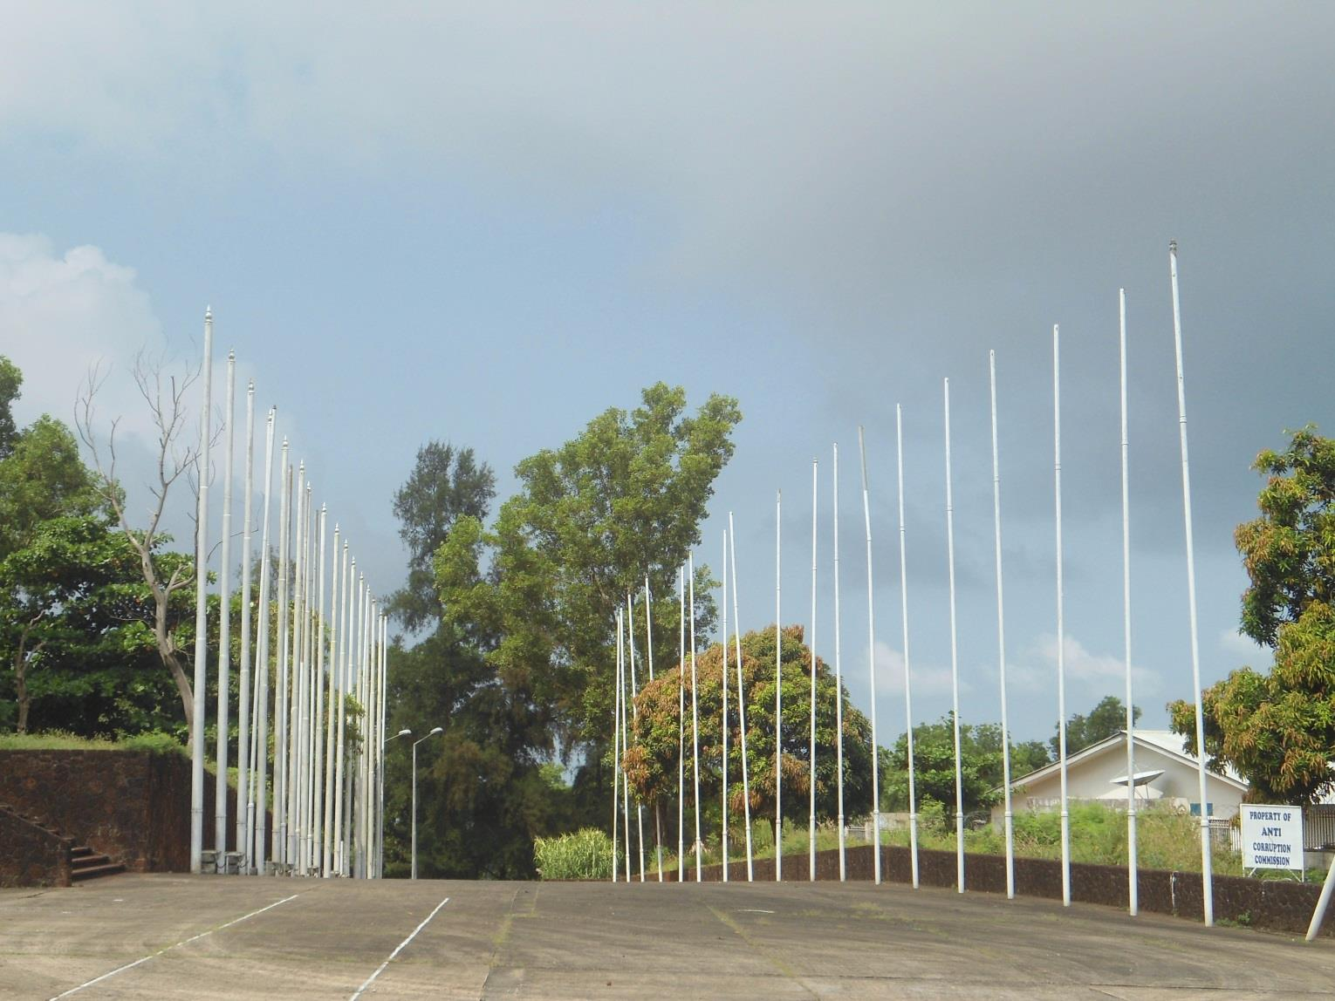
The Forecourt where the President inspect the Guard of Honour

These were known as the Official Members. The unofficial members were Charles Heddle, a European African and John Ezzidio, a Sierra Leonean.
Both the official and unofficial members constituted the Legislative Council which was responsible for enacting Laws for the colony.
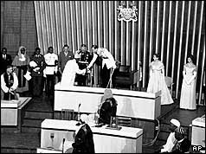
The Duke of Kent greets the Leaders at the Opening Ceremony of Parliament in 1961
But too much of executive powers were vested in the Governor.
Due to riots and strikes by railway workers, more anti-colonial pressure was mounted, which led to the formation of the National Congress for West Africa in 1920 with men like F.W Dove, a business man and H.C Bankole Bright, a Medical Doctor.
This congress demanded for a party elected legislative council in each colony; – this however met with failure even when the delegation was sent to London to press for action.
The Protectorate by then was legally regarded as a foreign country.
This historic process was ongoing when a governor came onto the scene by the name of Sir Ransford Slater. He was prepared to concede to the demand for popular representation but to him it was absurd to have a legislator for both colony and protectorate.
To satisfy their demands, Governor Slater planned a new constitution in 1924 which conceded the elective principles for colony, with some protectorate representation by chiefs.
Under the tribal system no other would have adequate title to speak with authority.
Membership of the legislature was increased to 21 with 3 paramount chiefs. From the 21 Members, 11 were appointed by the Government added to 10 unofficial Members.
Out of the 10 unofficial Members, 5 were Colony Representatives elected from among the educated Creole elites and the 3 Paramount Chiefs from the Protectorate nominated by the Governor. This registered a significant development for African representation in the Legislative Assembly.
In 1951, further constitutional development was made by Governor Beresford Stoke, which increased the Paramount Chiefs representation in the Legislative assembly to 12, one, for each district, a practice that prevails today.
After the Sierra Leone Peoples Party (SLPP) victory in 1951 election, some members were appointed to the Executive Council.
In 1954, the leader of the party, Sir Milton Margai was made Chief Minister and the other members of the council became ministers.
After independence in 1961, Sierra Leone Parliament continued to evolve. It became a completely elected body. By then the office was located at the mechanized section of the Treasury Building, at George Street in Freetown, which was our first Parliamentary building.
The present chamber of Parliament was opened by the Duke of Kent in the eve of Sierra Leone Independence celebration.
Apart from the Paramount Chiefs that were indirectly elected through an Electoral College System, all Members of Parliament were elected by an electoral system, based on a single member constituency.
The defining parameter for the delimitation of electoral boundaries was population quota, based on the most recent census results.
Up to 1967, the Sierra Leone Peoples Party which had the majority in Parliament, constituted the Executive. In 1968, after the controversial 1967 elections, the All Peoples Congress (APC) commanded the majority in the House.
Under the leadership of Siaka Probyn Stevens, the APC government undertook certain constitutional reforms that altered significantly the British set-up of the Sierra Leone Parliament.
In 1971, Sierra Leone assumed a republican status with an Executive Presidency that doubled as Head of State and Government. Parliament was most profoundly affected by this constitutional adjustment.
The implication was that the Parliament would no longer be involved in the formation of the Executive. They became two separate arms of government.
In 1978, Sierra Leone was transformed into a one-party state. This meant that Parliament was dominated by a single party.
The APC became the only political party that was constitutionally recognized. All other parties were disbanded. Members of Parliament from the opposition SLPP had only two options amidst this constitutional change.
They were to either switch allegiance to the APC and remain in Parliament or resign their seats. Most of them chose the former. Thus, from 1978 – 1992, the Sierra Leone Parliament was without an official opposition.
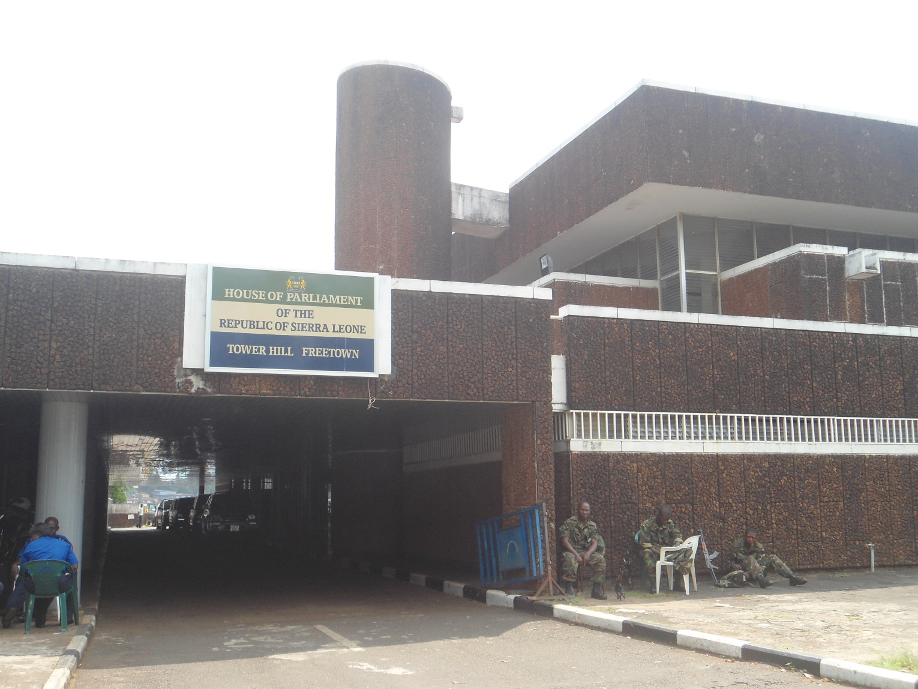
The Back View that is presently used as main entrance to the House of Representatives

In 1991 a new constitution was adopted, allowing for a transition towards multiparty elections. Political parties started to register in preparation for elections.
The 1991 multiparty constitution was not however implemented. Fighting with the rebel movement, the Revolutionary United Front (RUF), which had started in March 1991, escalated. There were also incursions from neighboring Liberia where the RUF in the south of the country was being loosely in alliance with Liberian rebels.
In April 1992, Captain Valentine Strasser took control after a coup by junior army officers, during which the activities of Parliament and the constitution were indefinitely suspended.
The legislative role of Parliament was substituted with the passing of decrees by a military council.
The Rebel war intensified despite air and ground support from Nigeria, and troops provided by Guinea, At one point in 1995 the government was in secure control of only the capital. In January 1996, Strasser was overthrown by his deputy Brigadier Julius Maada Bio.
The period of inactivity by Parliament was brought to an end with the restoration of constitutionality in 1996.
The military yielded to pressure from within and without to return the state to civilian rule under a system of multiparty democracy. There was however a review of the electoral system to determine membership in Parliament.
The war inhibited the conduct of a census to determine the redistribution of constituencies. An ad hoc electoral arrangement was adopted to elect Members of Parliament in 1996.
Parliamentary and Presidential elections under the 1991 multiparty constitution were finally held in February 1996.
In a two-round presidential election the SLPP candidate, Ahmad Tejan Kabbah, defeated UNPP’s Dr. John Karefa-Smart and Kabbah was sworn in as president at the end of March 1996.

It was the Proportional Representation (PR) electoral system where parties rather than constituencies, determined election to parliament. In 2002, the PR system of election was replaced by the District Block Electoral System (DBS). Both electoral systems did not adequately obligate MPs to their constituents as popularity within their parties was more important than popularity among constituents or the people.
The 2007 elections in Sierra Leone have been widely acclaimed as having been historical and significant in several senses, including their conduct along the lines of the first-past-the post-electoral system.
The elections registered the reintroduction of the constituency electoral system that was interrupted by the exigencies of war between 1991 and 2002.
The current Parliament that emerged from the electoral system saw the first litmus test of the spirit and intent of the 1991 Constitution (Act No.6 of 1991). Section 38 (1) and (2) of the 1991 Constitution explicitly states that:
“Sierra Leone shall be divided into such constituencies for the purpose of electing the Members of Parliament referred to in paragraph (b) of subsection (1) of section (74) of this Constitution as the Electoral Commission, acting with the approval of Parliament signified by resolution of Parliament, may prescribe.”
“Every constituency established under this section shall return one Member of Parliament.”
The last Parliament was the Fourth and the current is the Fifth Parliament of the Second Republic of Sierra Leone. This means that it is the Fifth Parliament since the restoration of constitutional rule.
The first was in 1996, second, 2002, third, 2007, fourth, 2012 and the fifth, 2018.
The change of parliaments is determined at every democratic election.
The First Republic was in 1971, when Sierra Leone was officially declared a republic.
The Second Republic was in 1996.
Presently, Parliament of Sierra Leone has a total number of 146 MPs including the 132 elected through the first-past-the post electoral system and the 14 Paramount Chiefs, one from each of the fourteen districts, i.e. Karene and North West added to the previous 12 districts.
This is in compliance with section 74 (1) of the 1991 Constitution of Sierra Leone and in line with tradition inherited from colonial rule.
This constitutional provision states that each district in Sierra Leone shall have one Paramount Chief Representation elected through a separate election.
The Parliamentary representation of the three parties in the Third Parliament (2007-2012) was as follows:

With the Fourth Parliament (2012 – 2017), only the two most prominent political parties succeeded in securing the people’s mandate, i.e. the SLPP (42) and APC (67) seats with a total of 15 women and 12 Paramount Chiefs.
During the Fourth Parliament the National Electoral Commission in adherence to its constitutional mandate, delimited electoral constituency and ward boundaries, which is to be done “not less than five years and not more than seven years”, in compliance with the timeline as stipulated in its Electoral Calendar (2015-2019); NEC in consultation with Statistics Sierra Leone, undertook Constituency and Ward Boundary Delimitation and De-Amalgamation of Sierra Leone;
It was approved in Parliament in 2017 as the newly constituted constituencies, ward and district demarcations used in the 7th & 27th March, 2018 presidential, parliamentary, mayoral and head-men elections.
This makes provision for 132 directly elected Members of Parliament and 14 indirectly elected paramount chiefs, which sum up to 146 Members of Parliament which is the present Parliament.
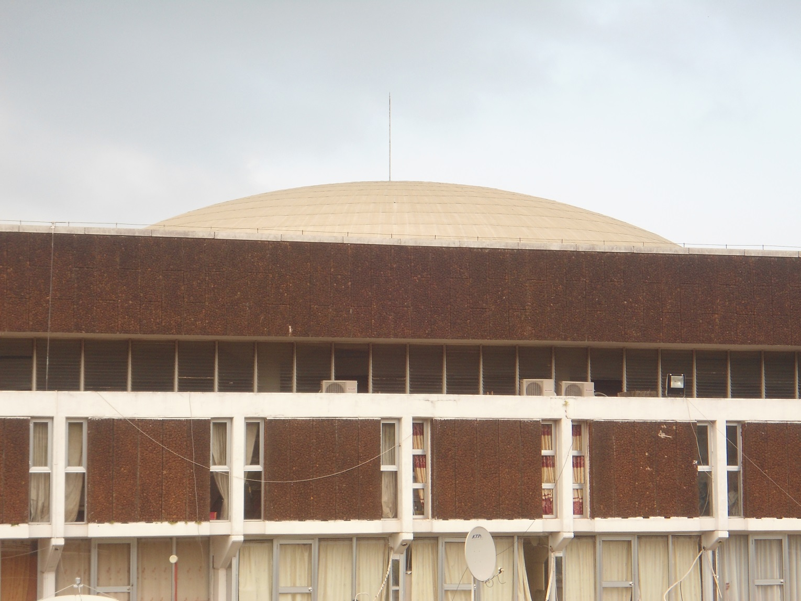
The side view of the monumental building showing the doom roof

The Al-Aqsa of Africa
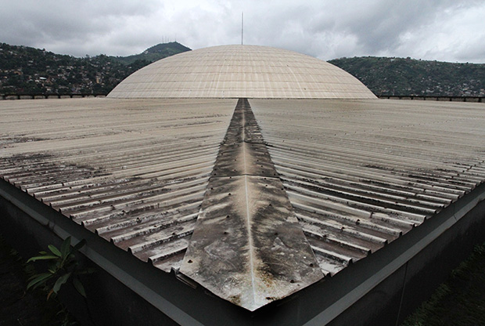
Top of the roof

The House of Parliament of Sierra Leone is a cubic citadel with a panoramic view of the Freetown harbor. Situated on the hilltop of Tower Hill, the complex has an assembly hall, members lounge, library, committee rooms, offices, cafeteria, and terraces. The building is an example of Brutalist architecture, a style that had its zenith from the 1950s to the mid-1970s, characterized by sharp geometrics and a rough concrete surface that reveals the imprint of the structure’s wooden frame.
The coffee-colored parliament building is also a symbol of the State of Israel’s long-running engagement in Africa. Israel’s foreign-aid program began in 1958 with a small department in the nation’s foreign office. The motivation to develop strong ties with post-colonial states became a political emergency after the Bandung Conference in Indonesia.

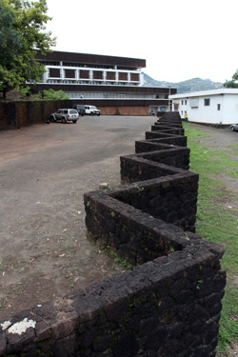
A Wall on the compound

In 2012 Cyril Juxon-Smith, Director of Public Relations at Sierra Leone’s Parliament, bumped into a high-level Israeli diplomat casually “having a look” around the parliament complex. She was immediately escorted to the parliament clerk for an engaging conversation. “This building has been a blessing to our country since its construction. It stands strong, stoic, and solid. It seems as if it could withstand another five decades,” said Juxon-Smith. If diplomatic relations are restored, parliamentarians of the two nations will have more in common than they might think and plenty of unfinished business to talk about—starting with the roof.
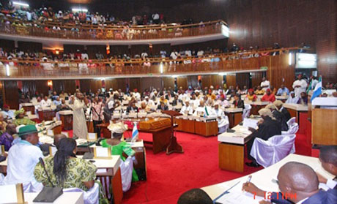
Plenary deliberations in progress

In 1996, the late Dr. Karefa-Smart, one of Sierra Leone’s most prominent politicians and its first foreign minister, told Peter J. Kulagbanda, who was Principal Clerk of Committees at Sierra Leone’s House of Representatives, now the Director of Committees, that the idea of constructing a new parliament building was his (Dr. John Karefa Smart’s).
Once it became imminent for the British to officially unhook its talons from its Crown Colony on April 27, 1961, Sierra Leoneans had less than a year to find a suitable venue for their legislative body and Independence Day Ceremony.
Dr. John Karefa-Smart approached the British with an idea to construct a parliament for the nascent government. It was their refusal—citing an unrealistic deadline—that led Sierra Leoneans to seek Israeli assistance.
With earmarked loans, the Israeli government financed almost half of the construction budget of £400,000, a naïve estimation that would later balloon to over £900,000. Solel Boneh, the construction arm of Histradrut, Israel’s largest trade union, was awarded the building contract. To oversee the project Israel created the National Construction Company (Sierra Leone) Ltd., a joint enterprise based in the capital city of Freetown.
The architectural firm Karmi, Melzer, & Karmi was commissioned for the parliament’s design. Dov and Ram Karmi, the father-and-son team who were also involved with the design of Israel’s own parliament, the Knesset, are footnoted in history as the architects of Sierra Leone’s Parliament. But it is Zvi Melzer, a partner in the firm, who gets credit as the architect on documents from Sierra Leone’s Ministry of Works. “It’s a very good example of the so-called Brutalist architecture,” said Zvi Efrat, an Israeli architect and architectural historian. “But this is an African building—an object out of a foreigner’s imagination of Africa.”
Indeed, Parliament of Sierra Leone has unusual characteristics that deviate from the Brutalist style. The Parliament’s façade is covered in pre-cut pieces of red stone, locally excavated from the hilltop, which gives the building its coffee color. “The dome is also an enigma. It’s a strange feature that has nothing to do with Brutualist architecture,” added Efrat, referring to the building’s saucer-shaped dome, which glistens like the al-Aqsa Mosque in Jerusalem. “When you usually see something like that, it almost has a religious significance—perhaps Jewish, perhaps Islamic. What is it doing on a civic structure?” Other Israeli touches include the beautifully crafted wood beams in the assembly hall, features Efrat often sees in boardrooms and conference halls across Israel.

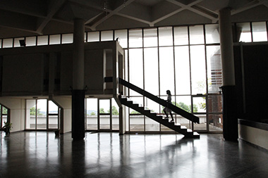
Interior Stairs

The entrance hall in Sierra Leone’s parliament is grand and spacious with high ceilings like an Italian palazzo that sits oddly with the country’s reputation as a developing country. The glass windows circling the main gallery send lances of sunlight over a staircase. Speaking of the building’s interior, Efrat said, “Here the architecture is reduced to the essentials: light, structure, free-standing elements in the space. Everything is very distinct. It’s beautiful.” The original plan called for three phases of construction: Phase 1 was the emergency project—the assembly hall needed for the Independence Day Ceremony in April 1961; Phase 2 was to include offices for all the Members of Parliament and quarters for staff; Phase 3 was finishes—but the project never made it that far.
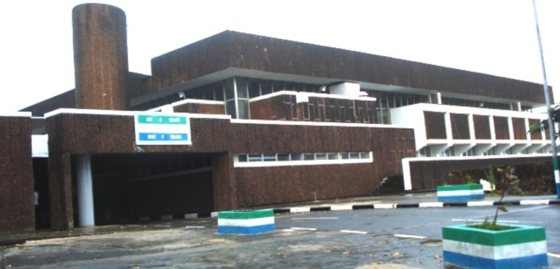
The Back Entrance

Held hostage by a fast-ticking clock, Sierra Leone’s Cabinet ministers gave the Israeli contractors carte blanche to work without a bill of quantities, a document detailing an itemized list of materials, costs of labor, and terms of construction. The expectation was that everything would be sorted out after the Independence Day Ceremony. Early in October 1960, Alexander Tzur, consul of Israel in Sierra Leone, sent a desperate cablegram to Israel’s ministry of finance complaining that a representative of Dizengoff, the firm Israel appointed as the executor of its funding toward the project, had not visited Freetown in over four months and was unresponsive when sent a visa. With the exception of woodwork crafted in Israel, important equipment and other construction materials had yet to be ordered. A month later, Tzur again contacted the ministry pleading that it was necessary for Dov Karmi to come to Freetown to adjust the building plans and to bring along a permanent representative who would shepherd the project until the Independence Day Ceremony. By February 1961, the architectural drawings were still missing.
R.L. Armstrong, Sierra Leone’s director of public works, contacted the Israeli company Solel Boneh to get to the heart of the matter. The constructor forwarded the diligent bureaucrat an ambiguous reply that led him to fire off a confidential memo to his colleagues stating, “The government is now in a position where it has no control over the contractor who is in fact carrying out [a] cost-plus contract without supervision.”
After eight months of bureaucratic intrigues, money squabbles, and construction circumventions, the Israeli contractors completed the assembly hall in the nick of time for the Independence Day Ceremony on April 27, 1961. On the eve of independence, the Duke of Kent gave a speech and presented a plaque at the opening ceremony of the assembly hall. The next day it rained and water leaked through the building’s unfinished areas; the Parliament still experiences leaks.
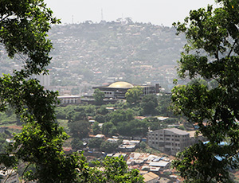
Freetown, Sierra Leone.
There was an opportunity for a proper refurbishment in 1996 when President Ahmad Tejan-Kabbah discussed completing Phase 2 of the Parliament’s construction.
A company from Côte d’Ivoire, claiming to be subsidiary of Solel Boneh, was given a tour of the complex. But before plans could materialize, a coup d’état erupted in Sierra Leone a year later. In 2004 a Chinese company was commissioned to refurbish the parliament and repair corroded pipes. But they couldn’t figure out certain aspects of the original engineering. A local supervisor assigned to monitor their work was allegedly fired after he asked too many questions. The original chairs in the assembly hall—still in excellent condition after nearly five decades—were plucked out, carted off in a truck to be sold, and shoddier replacements were brought in.
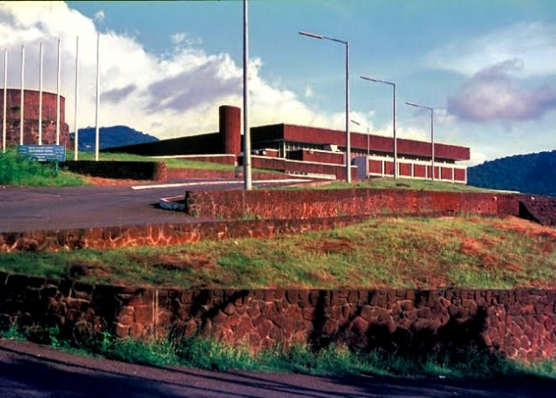
The back view

Parliament Election Chronicles since 1973 to 2018
First Parliament of the First Republic of Sierra Leone, Elections conducted on the 15th May, 1973
Elections were held to renew all the Members of Parliament, after their terms of office had been extended by one year and the previous elections had taken place in March 1967.
On the 18th April, 1973, His Excellency President Siaka Probyn Stevens dissolved Parliament and a state of emergency was declared throughout the country the next day in view of the upcoming electoral campaign. Nomination day was set for April 25. The rather troubled campaign was marked by accusations of intimidation of candidates filing their nomination papers.
The Sierra Leone People's Party, which had held 11 seats in the previous Parliament and figured as the major Opposition, altogether boycotted the election. As a result of the elections — the first since Sierra Leone became a republic in April 1971 — the All People's Congress (APC) emerged de facto as the country's sole party. It captured 84 of the 85 seats at stake, with the remaining seat taken by an Independent. The 12 Paramount Chiefs themselves traditionally join the Government.

Composition of the First Parliament of the First Republic
Political Parties | Membership
All Peoples Congress (APC) | 84
Independents | 1
Paramount Chiefs | 12
Total | 97

Members of Parliament according to Age Group
Range | Total
30-40 | 25
40-50 | 50
50-60 | 15
60-70 | 7
Grand Total | 97
Gender Representation
Gender | Membership
Men | 96
Women | 1
Total | 97

Second Parliament of the First Republic of Sierra Leone, Elections conducted on the 6th May, 1977
Parliamentary elections were held in Sierra Leone on 6 May 1977. They were the last multi-party elections held in the country until 1996.
Elections were called ahead of schedule by President Siaka Stevens following his declaration of a state of emergency after student riots earlier in the year.
In the election itself, only 41 of the directly elected and one of the indirectly elected paramount chief seats were contested (in the remaining 36 directly elected and 11 indirectly elected seats, the All People's Congress was the only party with a candidate). In a campaign marred by violence, elections in eight constituencies were not held on the day of the election, but were contested at a later date.
For the first time, there were also three presidential appointees in the parliament.
The following year, a referendum approved a new constitution that made the country a one-party state with the APC as the sole legal party. Elections were held under this system in 1982, 1985 and 1986. Another referendum in 1991 returned the country to multi-party politics, and the next pluriform elections were held in 1996.

Composition of the Second Parliament of the First Republic, 6 May, 1977
Political Parties | Membership
All Peoples Congress (APC) | 70
Sierra Leone Peoples Party (SLPP) | 15
Democratic National Party (DNP) | -
Independents | -1
Presidential Appointees | 3
Total | 100

Third Parliament of the First Republic of Sierra Leone, Elections conducted on the 1st May, 1982
Parliamentary elections were held in Sierra Leone on 1 May 1982. They were the first elections since the country had become a one-party state under the 1978 constitution, with the All People's Congress being the sole legal party.
Following an amendment to the constitution in 1981, prior to the election, primaries were held to choose up to three candidates (all selected by the APC) to stand in each of the 85 constituencies, As a result, elections in 66 of the 85 constituencies were contested (13 of the 19 seats left uncontested were held by cabinet ministers).
The elections were marred by violence in which up to 50 people died. The APC used the army to crush opposition SLPP supporters in what became known as the "Ndogboyosoi [bush devil] war"
In addition to the 85 elected seats, the parliament consisted of 12 paramount chiefs elected through tribal councils and 7 MPs appointed by the president, Siaka Stevens.
The results in 13 constituencies were cancelled due to "serious irregularities". By-elections took place on June 4.
40 sitting MPs and two ministers lost their seats, whilst a woman was elected to parliament in a constituency seat for the first time
Composition of the Third Parliament of the First Republic, 1 May, 1982
Political Parties | Membership
All Peoples Congress (APC) | 85
Paramount Chiefs | 12
Presidential Appointees | 7
Total | 104

Fourth Parliament of the First Republic of Sierra Leone, Elections conducted on the 29th & 30th May, 1986.
Parliamentary elections were held in Sierra Leone on 29 and 30 May 1986. As the country was a one-party state at the time, the All People's Congress was the only party allowed to run. They were the last elections held under the 1978 constitution, as a 1991 referendum returned the country to multi-party politics.
The elections were held ahead of schedule following the early dissolution of parliament. This was reportedly done in order to "choose a Parliament that would reinforce the "new order" of economic reform and public probity advocated by the new President", Joseph Saidu Momoh.
Since the 1982 elections the parliament had been enlarged from 104 to 127 members, with an additional 20 elected MPs and a further three presidential appointees, The APC nominated 335 candidates to contest the elections, which had been due to be held on 15 and 16 May, There were around 2 million registered voters.

Composition of the Fourth Parliament of the First Republic, 29 May, 1986
Political Party | Membership
All Peoples Congress (APC) | 105
Paramount Chiefs | 12
Presidential Appointees | 10
Total | 127

First Parliament of the Second Republic of Sierra Leone, Elections conducted on the 26th & 27th February, 1996.
General elections were held in Sierra Leone on 26 and 27 February 1996 to elect a President and members of Parliament. A second round of voting in the presidential election was held on 15 March. It was the first election since multi-party politics had been reintroduced following a referendum on a new constitution in 1991, and the first multi-party election held in the country since 1977.
The parliamentary elections were won by the Sierra Leone People's Party, which returned to power after a 29-year absence. The All People's Congress, which had governed from 1968 to 1992 (from 1978 to 1991 as the sole legally permitted party) finished fourth. The presidential election was won by the SLPP's candidate, Ahmed Tejan Kabbah. However, he was deposed by a coup led by Johnny Paul Koroma on 25 May 1997. On 10 March 1998 Kabbah was returned to power by Nigerian-led ECOWAS forces.
The SLPP won the most seats in the elections, but fell well short of a majority, with only 27 of the 68 elected seats.
Composition of the First Parliament of the Second Republic, 26 February, 1996
Political Parties | Membership
Sierra Leone Peoples Party (SLPP) | 27
United National People’s Party (UNPP) | 17
Peoples Democratic Party (PDP) | 12
All Peoples Congress (APC) | 5
National Unity Party (NUP) | 4
Democratic Centre Party (DCP) | 3
Paramount Chiefs | 12
Total | 80
Gender Representation
Men | 75
Women | 5

Second Parliament of the Second Republic of Sierra Leone, Elections conducted on the 14 May, 2002
For the first time since the civil war was declared officially over in January 2002, elections were held for all seats in Parliament. General elections had previously been held in February 1996.
Five months after the civil war was officially declared over, more than 2 million voters went to the polls on 14 May 2002 to elect a new President of the country and the 112 directly elected members of Parliament.
Although the electoral campaign was quite peaceful, there was a clash three days before the polling day between supporters of the former rebel group and now a political party, the Revolutionary United Front Party (RUFP) and the ruling Sierra Leone People’s Party (SLPP). After this event, leaders of seven political parties and the National Electoral Commission signed a joint statement condemning the violent clashes and urging supporters of political parties “to refrain from any acts or threats of violence and intimidation.”
Final figures released by the National Electoral Commission (NEC) showed that 2,329,161 persons were registered to vote in the elections, including some returned refugees who were eligible for late registration. Nineteen parties were registered by the NEC, but only ten contested the parliamentary elections.
Election officials noted some irregularities but no violence on the polling day. The most serious breach reported was one presiding officer at one polling station apparently thumb-printing an untold number of ballot papers. International observers also declared that there had been some irregularities, including under-age voting and possible double-voting. One universal complaint, by international and local observers, was that more civic voter education was needed. Despite a poster campaign, sponsored by the United Nations and other organizations, many voters still did not know how to fill in their ballot papers. But all agreed that the polls were by far the most peaceful in the country since independence from the United Kingdom in 1961. The Special Representative of the United Nations Secretary General in Sierra Leone praised the organization of the election and the way people had behaved.
President Ahmad Tejan Kabbah won the presidential election, triumphing as the man who brought peace to the country after a decade of civil war.
In Parliament, 83 of the 112 seats at stake went to the Sierra Leone People’s Party (SLPP), giving it an absolute majority. The All People’s Congress (APC) took 27 seats in the North and the West districts of the country, while the Peace and Liberation Party took the two remaining seats. None of the other seven political parties, including the former rebels of the Revolutionary United Front, reached the 12.5 percent threshold needed in any electoral district to enter Parliament.
On 10 June 2002, the twelve traditional leaders from the twelve districts were elected to seats in Parliament reserved for paramount chiefs.
On 25 June 2002, Parliament held its first sitting and re-elected Hon. Justice Edmond Kadoni Cowan as its Speaker.
Composition of the Second Parliament of the Second Republic, 14 May, 2002
Political Parties | Membership
Sierra Leone Peoples Party (SLPP) | 83
All Peoples Congress (APC) | 27
Peace and Liberation Party (PLP) | 2
Paramount Chiefs | 12
Total | 124
Gender Representation
Men | 106
Women | 18
Percentage | 14 %

Third Parliament of the Second Republic of Sierra Leone, Elections conducted on the 11 August, 2007
General elections were held in Sierra Leone on the 11th August 2007, Seven candidates competed in the first round of the presidential election; no candidate received the necessary 55% of the vote to win in the first round, and a second round was held between the top two candidates, Ernest Bai Koroma of the All People's Congress (APC) and Solomon Berewa of the Sierra Leone People's Party(SLPP), on 8 September. According to official results, Koroma won the election with 54.6% of the vote.
566 candidates stood in the Parliamentary election, in which 112 seats, out of a total of 124, were at stake. Voting for seats in parliament were done on a first-past-the-post constituency basis, rather than the system of proportional representation used previously.
The 124 Members of Parliament were sworn in on September 25. Hon. Justice Abel Stronge was elected as Speaker and the APC's Victor Chukuma Johnson was elected as Deputy Speaker. Edward Turay was chosen as Leader of the Majority Party, and Momoh Pujeh was chosen as Leader of the Minority Party.
Composition of the Third Parliament of the Second Republic, 11 August, 2007
Political Parties | Membership
All Peoples Congress (APC) | 59
Sierra Leone Peoples Party (SLPP) | 43
Peoples Movement for Democratic Change | 10
Paramount Chiefs | 12
Total | 124
Gender Representation
Men | 108
Women | 16
Percentage of Women | 12.90 %

Fourth Parliament of the Second Republic of Sierra Leone, Elections conducted on the 17 November, 2012
General elections were held in Sierra Leone on 17 November 2012, the result was a victory for incumbent President Ernest Bai Koroma of the All People's Congress (APC), who received 58.7% of the vote.
Composition of the Fourth Parliament of the Second Republic as at 7th December, 2017
Political Parties | Membership
All People’s Congress (APC) | 70
Sierra Leone People’s Party (SLPP) | 42
Paramount Chiefs (12-Districts) | 12
Total | 124
Gender Representation
Men | 106
Women | 15
Women Percentage | 12.40 %
Number of Women
All Peoples Congress | 8
Sierra Leone Peoples Party (SLPP) | 7

Fifth Parliament of the Second Republic of Sierra Leone, Elections conducted on the 7th March, 2018
Composition of the Fifth Parliament of the Second Republic as at 11th April, 2018
Political Parties | Membership
All People’s Congress (APC) | 68
Sierra Leone People’s Party (SLPP) | 49
Coalition for Change (C4C) | 8
National Grand Coalition (NGC) | 4
Independents | 3
Paramount Chiefs(14-Districts) (PCMP) | 14
Total | 146
Women Representation
All Peoples Congress | 8
Sierra Leone Peoples Party | 6
Coalition for Change | 1
Independent | 1
Paramount Chiefs | 2
Total | 18
Percentage | 12%
Members with Visible Disability
All Peoples Congress (APC) | 1
Sierra Leone Peoples Party (SLPP) | 0
Coalition For Change (C4C) | 2
National Grand Coalition (NGC) | 0
Independents Members | 0
Paramount Chiefs (PCMP) | 0
Total | 3

Profile of the Fifth Parliament of the Second Republic as at 10th June, 2018.

Age Profile
The oldest MP is 83 years and the youngest is 29 years. The average age of the new Parliament is 48 years. This is below the average age of MPs across the world which stands at 53 years. See table below on age disaggregation;
Age bracket | Total MPs | %
18-35 | 11 | 8%
36-55 | 103 | 70%
56 above | 32 | 22%

Innings
The new Parliament has limited experience as a result of the high attrition rate. Out of the 146 MPs (Elected & Paramount Chief Representatives), 33(23%) have either come for the second or third term while 113 (77%) are new comers. The table below shows innings by political parties and Paramount Chiefs regarding experience in Parliament:

Party | Male | Female | Total | %
SLPP | 8 | 2 | 10 | 30%
APC | 17 | 1 | 18 | 55%
Paramount Chief | 4 | 0 | 4 | 12%
Independent | 1 | 0 | 1 | 3%

Educational level Attained
The highest educational level of the MPs is Doctor of Philosophy (PhD) and 7 MPs (5%) have PhDs. A total of 46 MPs (31%) have Master’s Degree while 8 (5%) have LLBs. 36 MPs (25%) have First degrees. The other 49 (34%) of MPs have Higher Certificate, Certificate and Advanced & Ordinary Level qualification. The constitutional eligibility of MPs is ‘to read and write’. All 146 MPs meet the eligibility criteria of becoming MPs. See chart below:

Procedure in the Chamber of Parliament:
Order Papers, Votes & Proceedings, Hansards, Bills, Govt. White-paper, and other relevant documents are being sent to MPs’ pigeon holes informing them about the programs for the coming sitting.
Plenary Proceedings
Parliamentary debate processions led by the Sergeant At Arms followed by the Speaker, the Clerk of Parliament and the Table Clerks
Prayers said by the Clerk of Parliament
Suspension of Standing Orders S.O. 5(2) if it has passed 10:00 am
Records of votes and proceedings
The speaker moves the motion for the adoption of votes and proceedings
Papers laid on the Table,
Motions being moved by MPs,
Bills laid by Ministers and moved for the first reading,
Questions proposed and put forward that the bill be read for the first time;
Motion agreed and the bill goes to the second reading,
The Minister proposes that the bill be read for the second time; By presenting the objects and reasons to the House, he/she moves its Second Reading,
MPs on both sides of the aisle now deliberate on the bill effectively,
Suspension of standing orders S.O. 5(2) for proceedings to continue during lunch time,
The minister responds to the issues raised by MPs and moves again that the bill be read the second time,
A motion moved on S.O. 51(1), Committal of the bill to the Legislative Committee, Question put and agreed for bill to be committed to the legislative committee,
MPs stand on S.O 23, personal explanations on issues affecting the state such as roads, electricity, security, water etc., and important personal issues.
Announcements by the Table Clerks,
The Speaker adjourns the House to another date, sometimes ‘Sine Die’.
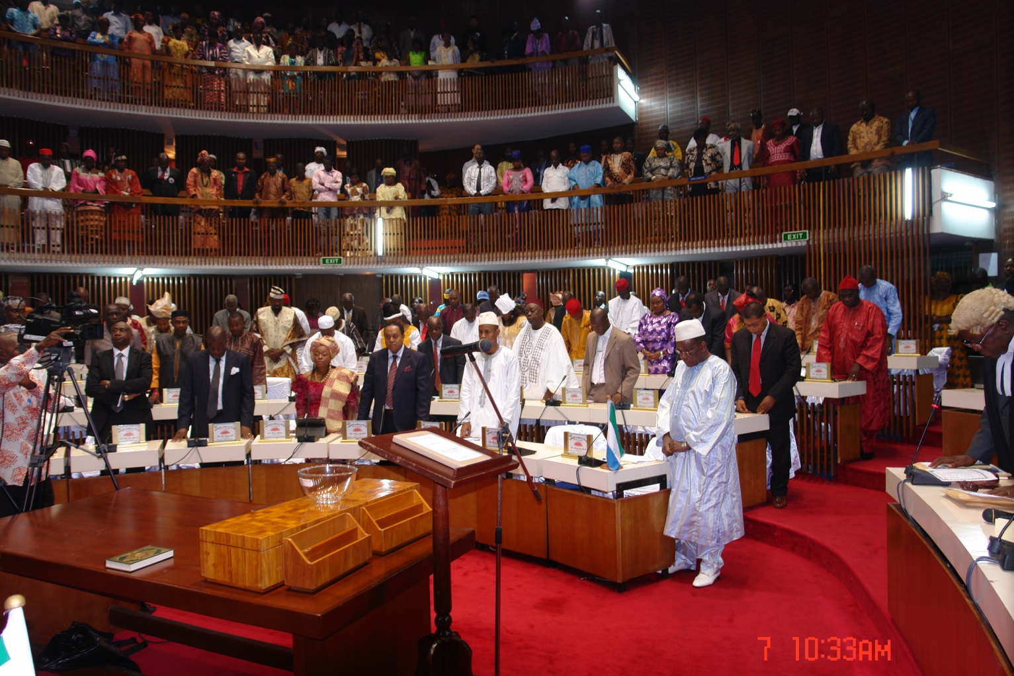
Members of Parliament & visitors standing for prayers

Summary on How a Bill Becomes Law
The Minister initiating the bill sends it to Law Officers Department for legal drafting preparations etc.
After drafting from Law Officers Department, the Minister submits the drafted bill at Cabinet for their input and approval
The draft bill is submitted to the Law Officers Department again for possible additional input from Cabinet
The draft bill is submitted to the Government Printer for gazetting on at least two consecutive dates/times for a minimum period of nine days and made available for public purchase.
The Minister then arrange with Parliament for a pre-legislative briefing. This is to enable the Minister discuss the details of the bill and its entirety with MPs before the bill is formally submitted for legislative proceedings.
The bill will be read the first time by the Minister, in the case of a Government Bill or by a private Member, in the case of a Private Member’s Bill. At this stage, only the title and general principle of the Bill are read.
After this stage the Bill is read the second time. The merits of the Bill are discussed in detail and debate commences.
Committee stage: The Bill will be examined clause by clause and technical and legal aspects reviewed, as they relate to existing legislations. The Committee of the Whole House reports to Parliament.
The Minister commits the bill to the third stage/reading and recommends that the bill be read the third time and passed into law.
After the bill has been unanimously passed by Parliament it is further taken to the Law Officers Department to effect any necessary amendments made by Parliament and sent to the Government Printer for draft assent copy.
The Clerk of Parliament certifies the assent copy and sends it to the President for his assent
The bill then becomes law, as an Act of Parliament, with the signature of the President
Thereafter, the Clerk of Parliament will forward the assent copy to the Government Printer for gazette publication. This publication will be available for sale at the Government Bookshop.

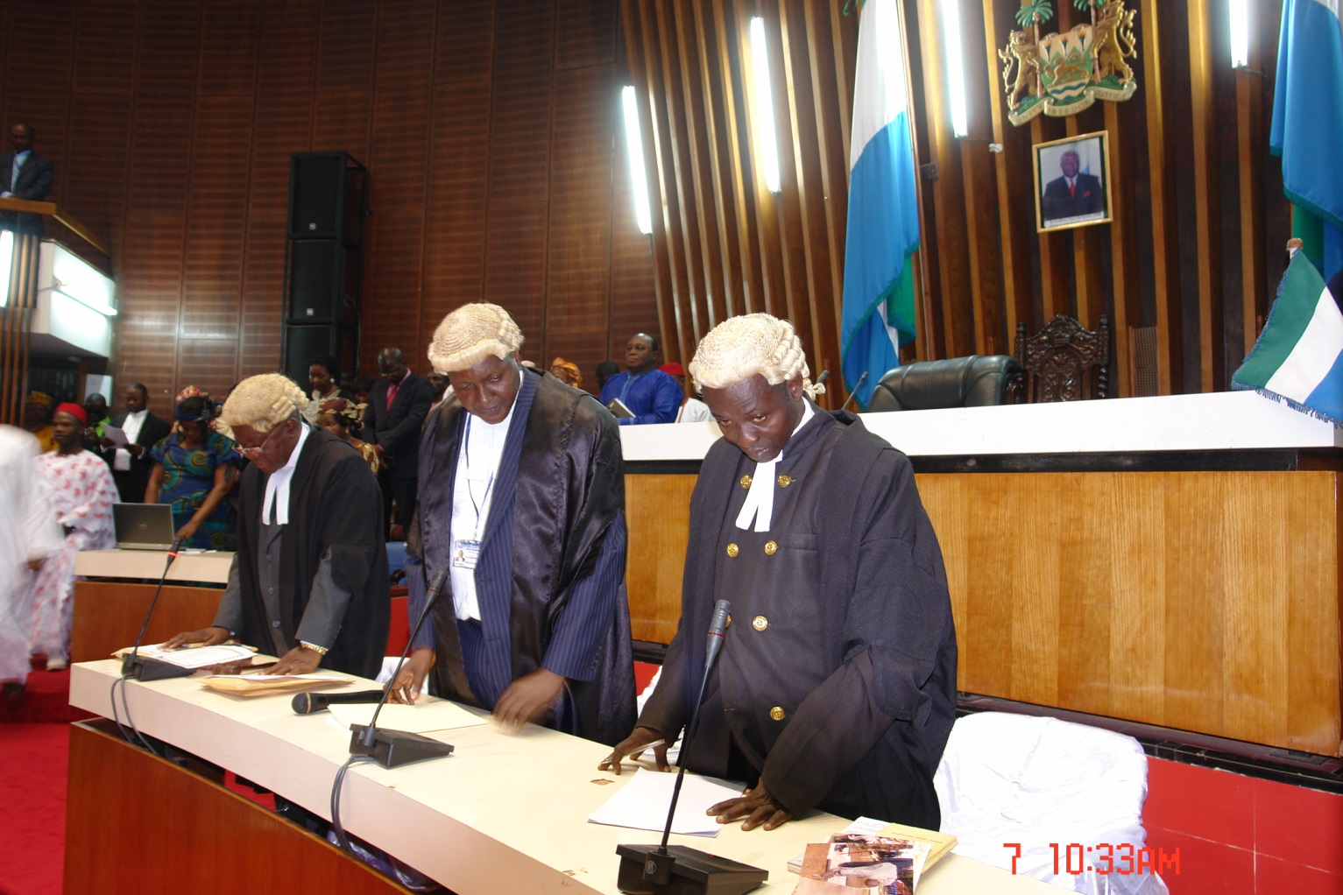
Clerks at the Table

SESSIONAL STATISTICS FROM 2012 TO 2017
FIRST SESSION OF THE FOURTH PARLIAMENT OF THE SECOND REPUBLIC OF SIERRA LEONE
TABLE 1: FIRST SESSION 7TH DECEMBER 2012 TO 19TH DECEMBER 2013
NO. OF SITTINGS | MOTIONS | ACTS | PRESIDENTIAL NOMINEES |  |  |  |  |  |  | S.O. 23 |  |  |  | LOANS & GRANTS  AGREEMENTS |  | STATUTORY/  CONSTITUTIONAL  INSTRUMENTS | ORDER  PAPERS | VOTES  AND  PROCEEDINGS | REPORTS LAID | OFFICIAL  REPORTS
61 | 42 | 19 | 91 |  |  |  |  |  |  | 13 |  |  |  | 27 |  | 10 | 61 | 61 | 19 | 61
SECOND SESSION OF THE FOURTH PARLIAMENT OF THE SECOND REPUBLIC OF SIERRA LEONE
TABLE 2: SECOND SESSION 20TH DECEMBER 2013 TO DECEMBER 2014
NO. OF SITTINGS | MOTIONS | ACTS | PRESIDENTIAL NOMINEES |  |  |  |  |  | S.O. 23 |  |  |  | LOANS & GRANTS  AGREEMENTS |  |  | STATUTORY/  CONSTITUTIONAL  INSTRUMENTS | ORDER  PAPERS | VOTES  AND  PROCEEDINGS | REPORTS LAID | OFFICIAL  REPORTS
63 | 57 | 14 | 109 |  |  |  |  |  | 33 |  |  |  | 34 |  |  | 5 | 63 | 63 | 17 | 63
THIRD SESSION OF THE FOURTH PARLIAMENT OF THE SECOND REPUBLIC OF SIERRA LEONE
TABLE 3: THIRD SESSION 5TH DECEMBER 2014 TO 9TH DECEMBER 2015
NO. OF SITTINGS | MOTIONS | ACTS | PRESIDENTIAL NOMINEES |  |  |  |  | S.O. 23 |  |  |  | LOANS & GRANTS  AGREEMENTS |  |  |  | STATUTORY/  CONSTITUTIONAL  INSTRUMENTS | ORDER  PAPERS | VOTES  AND  PROCEEDINGS | REPORTS LAID | OFFICIAL  REPORTS
63 | 53 | 11 | 171 |  |  |  |  | 31 |  |  |  | 23 |  |  |  | 12 | 63 | 63 | 25 | 63
FOURTH SESSION OF THE FOURTH PARLIAMENT OF THE SECOND REPUBLIC OF SIERRA LEONE
TABLE 4: FOURTH SESSION 11TH DECEMBER 2015 TO 13TH DECEMBER 2016
NO. OF SITTINGS | MOTIONS | ACTS | PRESIDENTIAL NOMINEES |  |  |  |  | S.O. 23 |  |  |  |  |  | LOANS & GRANTS  AGREEMENTS |  | STATUTORY/  CONSTITUTIONAL  INSTRUMENTS | ORDER  PAPERS | VOTES  AND  PROCEEDINGS | REPORTS LAID | OFFICIAL  REPORTS
52 | 30 | 16 | 87 |  |  |  |  | 14 |  |  |  |  |  | 25 |  | 5 | 52 | 52 | 25 | 52
FIFTH SESSION OF THE FOURTH PARLIAMENT OF THE SECOND REPUBLIC OF SIERRA LEONE
TABLE 5: FIFTH SESSION 15TH DECEMBER 2016 TO 7TH DECEMBER 2017
NO. OF SITTINGS | MOTIONS | ACTS | PRESIDENTIAL NOMINEES | PAPERS  LAID |  |  |  |  |  |  | S.O. 23 |  |  |  | LOANS & GRANTS  AGREEMENTS | STATUTORY/  CONSTITUTIONAL  INSTRUMENTS | ORDER  PAPERS | VOTES  AND  PROCEEDINGS | REPORTS LAID | OFFICIAL  REPORTS
70 | 38 | 22 | 41 | 64 |  |  |  |  |  |  | 12 |  |  |  | 56 | 84 | 70 | 70 | 31 | 70

How Parliament’s Committee System Works
The Tasks: A committee analyzes and evaluates the activities of government, carries out research in related fields and presents its findings to Parliament for debate and approval.

The Parliamentary Committee System
In all Parliaments in the world, time is of the essence. Hence much of the functions of Parliaments are performed through Committees of the House. It may be difficult to consider, in detail on the floor of the House, the legislative, oversight and deliberative functions of Parliament. A great deal of the business of the House is therefore transacted in Committees. MPs spend more time attending Committee meetings than attending Parliamentary sittings. Committees have made parliamentary work a full-time job for MPs.
A Parliamentary Committee is a small group of Members of Parliament, created and empowered by Parliament to perform a specified task. A Committee consists of Members drawn from political parties in Parliament based on the strength of their representation in the House. (Section 93(5) of 1991Constitution)
The Committees:
Hold their meetings in Parliament but may convene outside the precincts of Parliament with the permission of the Speaker;
Committees do not meet while the House is sitting but may sit while the House is adjourned for recess. (S. O.73 (7)
May determine its own subject for deliberation and for oversight (S.O.73 (5)
Committees are created by Parliament and hence enjoy the powers, privileges and protection that Parliament has under the Constitution. The rules of procedure contained in the Standing Orders 2006, (Revised) apply in equal measure to proceedings in plenary and the Committees. Hence, proceedings in a properly constituted Committee are recognized as proceedings in Parliament.
The Committee Department is headed by a Director, who works with a team of twenty (20) Committee Clerks to service the various Parliamentary Committees.

Establishment of Parliamentary Committees
Subsection 1 of Section 93 of the 1991 Constitution of Sierra Leone provides that:
“At the beginning of each session of Parliament, but in any case not later than twenty days thereafter, there shall be appointed…the following Standing Committees, that is to say
- Legislative Committee;
- Finance Committee;
- Committee on Appointments and the Public Service;
- Foreign Affairs and International Cooperation Committee;
- Public Accounts Committee;
- Committee of Privileges;
- The Standing Orders Committee and such other Committees of Parliament as the rules of procedure of Parliament shall provide.
Sub-section 2 of Section 93 provides for the establishment of Oversight Committees to parallel and oversee the Ministries, Departments and Agencies (MDAs) established by the executive. Each Committee bears the name of the MDA it oversees, e. g. Health and Sanitation Committee, Mines and Minerals Committee, etc.
By the provisions of Section 93 (4), there is no limitation in the powers of Parliament to create Committees. Parliament may at any time appoint any other Committee to investigate any matter of public importance.

Functions of the Oversight Committees
By the provisions of Section 93 (3), it shall be the duty of Committees set up under subsection (2) of the Constitution, “to investigate or inquire into the activities or administration of such Government Ministries or Departments as may be assigned to them and such investigation or inquiry may extend to proposals for legislation.”
To be more specific, they can review/scrutinize:
The laws governing the administration and general operations of the MDAs assigned to them;
The Programmes, plans, policy objectives and operations of the MDAs and the effectiveness of their implementation to scrutiny and debate;
The immediate, medium and long term expenditure plans of the MDA and the effectiveness of the budget execution thereof;
Analyse the relative success of the MDAs in meeting their objectives;
Scrutinize policy programmes, legislation and general oversight of the executive etc. etc.
Transparency Committee looks into adherence to administrative, financial and procurement procedures, conflict of interest, impropriety etc. etc.
The Legislative Committees plays an important role in the legislative process. (S.O.55-56)
Powers of the Oversight Committees
Pursuant to subsection (6) of Section 93 of the 1991 Constitution, each of the Committees enjoys the powers, rights and privileges of the High Court in respect of:
“Enforcing the attendance of witnesses and examining them on oath, affirmation or otherwise;
“Compelling the production of documents and “the issue of a Commission or request to examine witnesses abroad;
Make citation of contempt of Parliament for impeding the work of Parliament /Committees, for affronting its dignity; (Section 95 of Constitution)
The power to summon a Minister:
“To give an account of any matter falling within his portfolio or
To explain any aspect of Government policy” (Section 107 (2) of the 1991 Constitution) and S.O.76 (6)
Could allow strangers to attend meetings but the Committee Chairman may ask them to withdraw at any time during the deliberations of the Committee, S.O.73 (21)
The proceedings of a committee cannot be published until it has tabled its report in the House, S.O.75
Committees enjoy the relative independence of selecting their own subject matters for deliberation and for oversight functions. S.O.73 (5)

List of the Committees of Parliament
Domestic/Housekeeping Committees
- Committee of Selection
- Business Committee
- Standing Orders Committee
- House Committee
- Committee of Privileges
- Public Petition Committee
- Supervisory Committee

Departmental Oversight Committees
The Sierra Leone Parliament currently has thirty-one (31) Oversight Select Committees namely:
- Public Accounts Committee
- Committee on Appointments and the Public Service
- Finance Committee
- Legislative Committee
- Committee on Foreign Affairs & International Cooperation
- Committee on Political & Presidential Affairs
- Committee on Defense & Office of National Security
- Committee on Internal Affairs
- Committee on Works, Housing and Maintenance
- Committee on Transport and Aviation
- Committee on Local Government & Rural Development
- Committee on Education
- Committee on Agriculture and Food Security
- Committee on Mines and Mineral Resources
- Committee on Privileges
- Committee on Trade
- Transparency Committee
- Committee on Health and Sanitation
- Committee on Labour and Industrial Relations
- Committee on Lands and the Environment
- Committee on Fisheries and Marine Resources
- Committee on Information and Communication
- Committee on Energy
- Committee on Water Resources
- Committee on Human Rights
- Committee on Social Services
- Committee on Youth Affairs
- Committee on Sports
- Committee on Tourism and Cultural Affairs
- Committee on NGOs and NaCSa
- Committee on Sustainable Development Goals (SDGs

Procedures for the First Sitting of Parliament
Main Activities in Summary
Oath Taking of Elected Members of Parliament administered by the Clerk of Parliament.
Section 83 of the Constitution Act No. 6 1991provides that “Every Member of Parliament shall, before taking his seat in Parliament, take and subscribe before Parliament the oath as set out in the Third Schedule”
Election of the Speaker of Parliament
Qualifications as specified in the Constitution of Sierra Leone (Amendment) Act, 2013
Oath Taking of the Speaker of Parliament; As given in the Third Schedule of the Constitution of Sierra Leone (Act No.6 of 1991)
Election of the Deputy Speaker; As amended by the Constitution of Sierra Leone (Amendment) Act 2013
Oath Taking of the Deputy Speaker of Parliament
Felicitations to Hon. Speaker & Hon. Deputy Speaker

Chamber Procedure on the First Sitting
Mace Covered.
Officer-in-charge – Clerk of Parliament
The newly elected Members of Parliament take their seats in the Chamber of Parliament
The Clerk of Parliament offers Prayers
The Clerk brief Members of Parliament on the procedures for the Oath taking of elected Members.
Members of Parliament will take and subscribe to the Oath of Office as given in the Third Schedule Constitution (Act No. 6 of 1991)
This may be done in groups of 10 using Bible and Quran for both Muslims and Christians.
Next item on the Agenda will be the Election of the Speaker.

Procedures for the Speakership Election (Speaker and Deputy Speaker)
Election of Speaker is given under Section 79 of the Constitution of Sierra Leone
Section 79 was amended in 2013 by the Constitution of Sierra Leone (Amendment) Act, 2013 which now reads as follows:
79(1) The Speaker of Parliament shall be elected by the Members of Parliament from among persons who are-
(a) Members of Parliament and who had served as such for not less than five years; (b)Qualified to be Members of Parliament and who had served as such for not less than ten years; & who are not less than 40 years.
79 (2) The Speaker shall be elected by a resolution in favour of which there are cast the votes of not less than two-thirds of the Members of Parliament:
Provided that if three successive resolutions proposing the election of a Speaker fail to receive the votes of two-third of the Members of Parliament , the Speaker shall be elected by a resolution passed by a simple majority of all the Members of Parliament.

Election Process
Call for nominations by the Clerk of Parliament
Closure of nominations by Clerk of Parliament
Voting
Counting
Declaration

Nomination Process
The Clerk of Parliament calls for Nomination
A Member of Parliament nominates a candidate for the position of Speaker and will be seconded by a Member of Parliament based on the qualification specified. Any number of nominations may be made provided they are qualified.
Closure of Nomination
In the absence of any other nomination the Clerk will call upon a Member to move for the closure of nomination which is seconded by a, Member.
The Clerk will list the qualification as given in the constitution of Sierra Leone (Amendment) Act 2013).
The Table Clerk will note the names of Nominees and list them down and give them to the Clerk of Parliament
Question put and agreed to that Nomination be closed.
CLERK OF PARLIAMENT DECLARES NOMINATION CLOSED
VOTING
VOTING
VOTING is done as per Standing Order 8:
Blank ballot paper will be given to MPs by the Table Clerks.
Voting is done by secret ballot with words written (Aye – Yes) and (Nay – No)

SAMPLE BALLOT PAPER FOR THE ELECTION OF THE SPEAKER OF PARLIAMENT
FIRST SESSION, FIRST MEETING OF THE 5TH PARLIAMENT OF THE SECOND REPUBLIC OF SIERRA LEONE
ELECTION OF THE SPEAKER OF PARLIAMENT

NAY (NO)
AYE (YES)
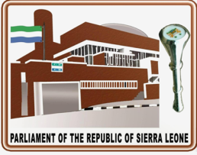

Clerk will explain the Voting process to Members and explain the meaning of ticking the box AYE – Meaning YES and NAY – Meaning No to select or reject a candidate.
The Clerk of Parliament proposes the question:
Hon Members the question is that the Hon. or Mr.………do take the Chair as Speaker of Parliament, if more than one person is so proposed the Clerk shall propose the question that the first person proposed do take the Chair of the House as Speaker.
Debate may be allowed under Standing Order 8 (4) for those who indicate their desire to speak.
The Clerk shall then call the names of Members in Alphabetical order and each, who so desire shall as his name is called, come to the table and drop his ballot paper into a glass jar in such manner as not to disclose how he is voting.
When all Members have dropped their ballots papers into the glass jar, the Clerk assisted by the Clerks at-the-Table shall examine the ballot papers and report the result to the House.
If the vote of less than 2/3 of the Members of Parliament are cast in favour of any question put to the House, the Clerk shall declare that that question has not been agreed to.
The Clerk shall then propose the same question until one such person is declared elected by the Clerk.
If three successive resolutions proposing the election of a Speaker fail to receive the votes of two thirds of all the Members of Parliament the Speaker shall be elected by a resolution passed by a simple majority of all the Members of Parliament, in a contest, (in the case of three candidates in the three previously negative resolutions), between the two candidates who received the highest and the next highest number of votes in the previous ballots.
If this question is not agreed to, the Clerk shall forthwith adjourn Parliament without question put and another election to the Speakership with new candidate shall be restarted in another Sitting.
If only one candidate is nominated voting shall take place by secret ballot in order to obtain the 2/3 majority.

STANDING ORDER (9) AND THE CONSTITUTION OF SIERRA LEONE (AMENDMENT) ACT 2013 (SECTION 80 AMENDED)
9. Election of Deputy Speaker
The election of a Deputy Speaker shall be conducted in a similar manner to the election of a Speaker, save that Mr. Speaker shall preside, and that any motion for the election of the Deputy Speaker shall be declared to have been agreed to, if it is supported by the majority of Members present and voting.

The Budget Process
Introduction
Budget in democratic governance, refers to the statement on the Government’s fiscal and economic policy measures relating to its annual revenue and expenditure decisions. In Sierra Leone, the legal credence to the budget process is provided in Section 110 to 119 of the 1991 Constitution, Parliamentary Standing Orders 63 to 69, the Government Budget and Accountability Act 2005. Like in most other countries, there are generally four stages of the budget process in Sierra Leone: preparation, approval, implementation and evaluation. Sierra Leone Parliament is mainly involved in the approval stage and to a lesser extent in the evaluation, while those of preparation and implementation mainly rest with the executive.

Budget Preparation
The budget preparation starts with the issuance of a Circular (Budget Call Circular) to all Vote Controllers of Ministries, Departments and Agencies (MDAs) by the Financial Secretary of the Ministry of Finance at around June each year, requesting them to submit the financial proposals to the Budget Bureau no later than end of August. The Circular outlines the macroeconomic and policy guidelines of the Government and indicates ceilings to the Heads of Expenditure of the MDAs which they are encouraged not to exceed. This is followed by strategic planning wherein Vote Controllers and Management Teams of the MDAs prepare planned activities, objectives and expected outcomes for the ensuing financial year relating to Heads of Expenditure, especially for development programmes.
Then the Medium Term Expenditure Framework (MTEF) Technical Committee sits together with the MDAs to arrange their budgeted programmes and activities in line with the MTEF process (quarterly allocation per annum of a three year budget) ensuring that they budget for incomplete projects from the previous year(s) or that medium term projects are evenly projected into the following year(s). This is followed by public discussions on the budget proposals. Although the process at this stage is still mainly the business of the Executive, sometimes some Members of Parliament (MPs) and Councilors are invited by the Budget Bureau and the MDAs to participate in public discussions on their budget proposals to get views on the appropriateness or otherwise of their needs and selected priorities. The budget figures are then confirmed by the MDAs after budget hearings and submitted to the Budget Bureau as budget estimates for the Appropriation Bill for that financial year.

Budget Approval/Legislative Process
Step 1: Budget Speech/First Reading: The presentation of the Budget by the Government in Parliament is one of the most closely followed events in any Parliament. This is generally followed by an extensive debate which attracts wide public attention. The Minister delivers the Budget Speech (which is the First Reading) and lays the estimates on the Table of the House as a Bill, being “an Act to provide services for Sierra Leone for the Financial Year”. Thereafter, the Appropriation Bill journeys through the legislative process. The Appropriation Bill shall be put down for Second Reading (S.O. 63/3) for not less than two clear days.

Step 2: The Second Reading: After the First Reading (which comes in the form of a Budget Speech), five days are allotted for the Second Reading with the debate limited to the financial and economic state of the country and general principles of Government policy and administration as indicated by the Bill and its estimates. On the last day of the five allotted days at 14:30 the proceedings of the Second Reading are brought to an end with the necessary question put by the Speaker; unless if the debate comes to an end earlier.

Step 3: Committee of Supply: At the end of the Second Reading, the Bill is committed to the Committee of the Whole House which for the Appropriation Bill is called the Committee of Supply (S.O. 64/1 &2). The Finance Committee in Parliament takes the lead in organizing the process of the Committee of Supply by dividing Members into Sub Appropriation Committees (these are Sub Committees of the Committee of Supply or of the Whole House), fixing timelines for ensuing meetings and summoning Vote Controllers of MDAs to defend their Heads of Expenditure, taking into account expenditures for programmes and activities for the previous Financial Year (FY) and those for the current FY. This exercise takes into consideration the policies underlying the estimates, priorities, effective and efficient use of both human and financial resources, the constraints of the MDAs, the adequacy or inadequacy of these resources and report to the Committee of the Whole House.

Step 4: Third Reading/Enactment: After the Sub Appropriation Committees report to the House and where there is no notice of amendments, a motion for the Third reading is made by the Minister in charge which is decided without debate.

Budget Implementation
Budget implementation or execution is done under the hand of the Financial Secretary and supervision of the Budget Bureau and Accountant-Generals’ Department of the Ministry of Finance. The Budget Bureau prepares the quarterly budgetary allocations which are forwarded to the Accountant-Generals’ Department under the hand of the Financial Secretary as directives to allow the processing of payment vouchers to MDAs up to the amounts allocated. The MDAs on their part raise vouchers for their activities and programmes of expenditure to access and utilize their quarterly allocations. The PET forms are in line with the MTEF and Integrated Financial Management Information System (IFMIS) to ensure prudent financial management that monies are spent for the activities for which allocations are made.

Sub Appropriation Procedures and its Financial Provisions
At the end of the Fiscal year, the Minister of Finance will lay on the table of Parliament the Budget Speech, Profile, Financial Strategy Statement and the Appropriation Bill for the First Reading.
After that, it shall be put forward for the Second Reading with a 5 allotted days for continuous debate on the Second Reading.
The Appropriation Bill and the Allocated budget estimates given to MDAs will be sent to the Committee of Supply to carefully scrutinize the budget allocated to every MDA.
An open-ended questionnaire is sent out to all MDAs in line with S.O. 66(1).
Vote Controllers are requested to respond to questions relating to their budgetary allocations, state their challenges and provide a comprehensive summation of how they have been carrying out their mandates.
After the exercises the Minister will again move the motion for the Appropriation Bill to be Read the Third time. It will then be passed into law for government to undertake capital and recurrent expenditure.

The Financial Provisions (Excerpts from 1991 Constitution and the Standing Orders, Revised 2006)
63. Presentation, first Reading and Second Reading of Appropriation Bill
(1) There shall be submitted to Parliament by the Minister of Finance before the beginning of the fiscal year to which it refers, a budget which shall include the documents delineated in subsection 23 of the government Budgeting and Accountability Act, (Act No. 3 of 2005).
(2) All proceedings upon the Appropriation Bill subsequent to its first reading, which takes the form of the Budget speech, shall be subject to the provisions of the remaining paragraphs of this Order and of the next five succeeding Orders, (i.e. Standing Orders).
(3) After the Bill has been read the first time, it shall be put down for Second Reading not less than two clear days thereafter and five days shall be allotted for the Second Reading of the Bill. The debate shall be confined to the financial and economic state of Sierra Leone an the general principles of Government policy and administration as indicated by the Bill and its Estimates. At 14.30 hours on the last day, unless the debate is concluded earlier, the speaker shall put any question necessary to bring the proceedings on second reading to a conclusion.
(4) For the purpose of this Order and of S.O. No. 65 (allotment of Time in Committee of Supply) an allotted day shall be any day on which the consideration of the appropriation bill, whether by the House or in the Committee of Supply, stands as the first Public Business for that day, and on such a day no other Public Business may be taken.

64. Committee of Supply
(1) There shall be a Committee of the whole House to be called the Committee of Supply. The deliberations of the committee shall be in public.
(2) Without prejudice to the mandate of the Finance Committee in these Orders, the Estimates shall upon presentation to the House stand referred to the Committee of Supply and the Appropriation Bill upon being read a second time, shall stand committed to that Committee.
(3) To enhance the effectiveness of the scrutiny of Heads of Expenditure by the whole House, the Committee of Supply shall, pursuant to subsection (6) of Section 112 of the Constitution, incorporate a scrutiny by a number of Appropriation Subcommittees formed out of organizing the Membership of Parliament into groups.

65. Allotment of time in Committee of Supply
(1) There shall be allotted a maximum of five days for discussion of the Appropriation Bill in Committee of supply.
Provided that if the question on the Second Reading of the Bill was agreed to on a day earlier than the last day allotted for the debate on Second Reading, the day or days thus saved may be added to the days allotted under this paragraph. And the work of the appropriation subcommittees shall be outside this time-frame.
(2) Upon any day allotted under paragraph (1) of this Order, no dilatory motion shall be moved, except by a Minister or the Majority Party Leader of the House, upon any proceedings on the Appropriation Bill and such proceedings shall not be interrupted or postponed under any Order.
(3) Mr. Speaker may name the hour upon any day allotted under paragraph (1) of this Order at which proceedings upon any Head of Expenditure in the Schedules to the Bill, or any Schedule or on the clauses of the Bill, shall be concluded. If in the case of any Head or Schedule or of the clauses the hour so named is reached before the business concerned is disposed of, the Chairman shall put forthwith any question necessary to dispose of that business
Provided that if in the case of any Head or Schedule the proceedings thereon are concluded before the hour named, the next business may be

66. Procedure in Committee of Supply
(1) Preliminary to the deliberations of the whole House in committee, the Appropriation Subcommittees shall, working together with vote Controllers and their Accountants, examine a series of Heads of Expenditure allocated to them by the finance Committee. This exercise shall include consideration of the policies underlying the Estimates, their structures of priorities, efficient and effective use of both human and financial resources, the constraints of the organizations, the adequacy or otherwise of the financial allocations, and report to the whole House in Committee of Supply.
(2) On the consideration of the Appropriation Bill in Committee of Supply, the clauses of the Bill shall stand postponed until after consideration of the Schedule or Schedules, which shall be initiated by the appropriation Subcommittee reports on them.
(3) On consideration of the Schedules, each Head of Expenditure shall be considered with the appropriate Estimates, and any reference in these Orders to a sub-head or an item means a sub-head or an item in the Estimates of the Head then under discussion.
(4) On the consideration of a Schedule, the Clerk of Parliament shall call the title of each Head of Expenditure in turn and the Chairman, following the motion of the Minister in Charge, shall propose he question “That the sum of Le x For Head y stand part of the Schedule”. And unless an amendment is proposed under the provisions of the next succeeding Order, a debate may take place on that question. Any such debate shall be confined to the policy of the service for which the money is to be provided and shall not deal with the details of any item or subhead but may refer to the details or revenue or funds for which that service is responsible. At the conclusion of the debate on a Schedule or a group of Schedules, as the case may be, the Chairman shall forthwith put the question.
(5) When all the Heads in a Schedule have been disposed of, the Chairman shall put forthwith without amendment or debate, the question “that the Schedule (as amended) stands part of the Bill.”
(6) When the Schedule has been disposed of, the Chairman shall call successively, each clause of the Bill and shall forthwith propose the question “that the clause stand part of the Bill” and, unless a consequential amendment is required to be moved, that question shall be disposed of without amendment or debate.
(7) No amendment may be moved to any clause except any amendment consequential on an alteration in the total sum appropriated by any Head in the Schedule. Any such consequential amendment shall be moved by a Minister only, and may be moved without notice and the question thereon shall be put forthwith without amendment or debate. When the question on the last of any such amendments to a clause has been decided, the Chairman shall forthwith put the question “that the clause as amended stand part of the Bill” and that question shall then be decided without amendment or debate.
(8) When the question upon every clause of the Bill has been decided, the House shall resume without question put, the Minister in charge shall report the Bill (or the Bill as amended) to the House, and following the motion that the Bill be read the third time and passed into law, the speaker shall forthwith put the question.

67. Amendments to Heads of Estimates in Committee of Supply
(1) No amendment shall be moved in the Committee of Supply under this Order, unless one clear day’s notice has been given of it and it has been published in the Notice Paper.
(2) An amendment to any Head of Expenditure to increase the sum allotted thereto whether in respect of any item or sub-head or of the Head itself, may only be moved by a Minister who shall signify to the Committee the increase in accordance with paragraph (3) of S.O. No. 52 (functions of Committees on Bills). Every such amendment shall take the form of a motion “That Head …………….. be increased by Le………… in respect of sub-head ……………. item ………..”.
(3) An amendment to increase a Head whether in respect of any item or sub-head or of the Head itself shall take precedence over an amendment to reduce the Head in the same respect, and if it is carried, no amendment to reduce the Head in that respect shall be called.
(4) An amendment to any Head of Expenditure to reduce the sum allotted thereto in respect of any item therein may be moved by any Member and shall take the form of a motion “That Head ……………….. be reduced by Le…………….. in respect of or by leaving out sub-head …………… item ………….”.
(5) An amendment to reduce a Head in respect of any sub-head or by leaving out a sub-head shall only be in order if the sub-head is not itemized.
(6) An amendment to reduce a Head without reference to a sub-head therein shall only be in order if the Head is not divided into sub-heads.
(7) An amendment to leave out a functional Head shall not be in order and shall not be placed on the Order Paper.
(8) In the case of each Head, amendments in respect of items or sub-heads in that Head shall be placed upon the Order Paper and considered in the order in which the items or sub-heads to which they refer, stand in the Head in the Estimates.
(9) When notice has been given of two or more amendments to reduce the same item, sub-head or Head, they shall be placed upon the Order Paper and considered in the order of the magnitude of the reductions proposed, the amendment proposing the largest reduction being placed first in each case.
(10) Debate on every amendment shall be confined to the item, sub-head or Head to which the amendment refers, and after an amendment to an item or sub-head has been disposed of, no amendment or debate on a previous item or sub-head or that Head shall be permitted.
(11) When all amendments standing on the Notice Paper in respect of any particular Head of Expenditure have been disposed of, the Chairman shall again propose the question “That the sum of Le……….. for Head ………….. stand part of the Schedule”, or shall propose the amended question “That the increased/reduced sum of Le…………. for Head ………… stand part of the Schedule”, as the case may require. The debate on any such question shall be subject to the same limitations as apply to a debate arising under paragraph (4) of S.O. No. 66 (Procedure in Committee of Supply).

68. Third reading of Appropriation Bill
So soon as the Appropriation bill has been reported to the House, a motion for the Third Reading shall be made by the Minister in Charge. Such motion is not required to be seconded, and shall be decided without amendment or debate.

69. Supplementary Appropriation Bills
(1) Where, in respect of any financial year, it is found that the amount of moneys appropriated by the Appropriation Act for any purpose is insufficient or that the need has arisen for expenditure for a purpose which no amount of moneys has been appropriated by that Act, a supplementary estimate showing the sum of money required shall be laid before Parliament.
(2) Where in respect of any financial year, a supplementary estimate has been approved by Parliament in accordance with the provisions of subparagraph (1) of this Order, a Supplementary Appropriation Bill shall be introduced in Parliament in the financial year next following the financial year to which the estimates relate, providing for the appropriation of the sums so approved for the purposes specified in that estimate.
(3) the debate on the Second Reading of the Supplementary Appropriation Bill shall be strictly confined to the matters for which additional expenditure has been provided, and when the question thereon has been agreed to, the Bill shall not be committed, unless the House on Motion so commits for discussion that Schedule, if any, to the Bill, which incorporates expenditure for which Supplementary Warrants (contingencies) have not been issued, and the Question “that the Bill be now read a third time” shall be put forthwith without amendment or debate.
(4) The Minister may cause to be prepared and laid before Parliament estimates of revenue and expenditure of Sierra Leone for periods of over one year.

PARLIAMENT OF THE REPUBLIC OF SIERRA LEONE
PARLIAMENTARY PRAYER

Almighty God
Without whose help Labour is useless,
Without whose Light, search is vain,
We thine unworthy servants here gathered
Together in thy name,
Do most humbly beseech thee
To send down thine heavenly wisdom from above
To direct and guide us in all our deliberations
And laying aside all private interests, prejudices and partial affections,
The result of all our counsels
Maybe to the glory of thine blessed name.

SITTING POSITONS OF THE FIFTH PARLIAMENT OF THE SECOND REPUBLIC OF SIERRA LEONE
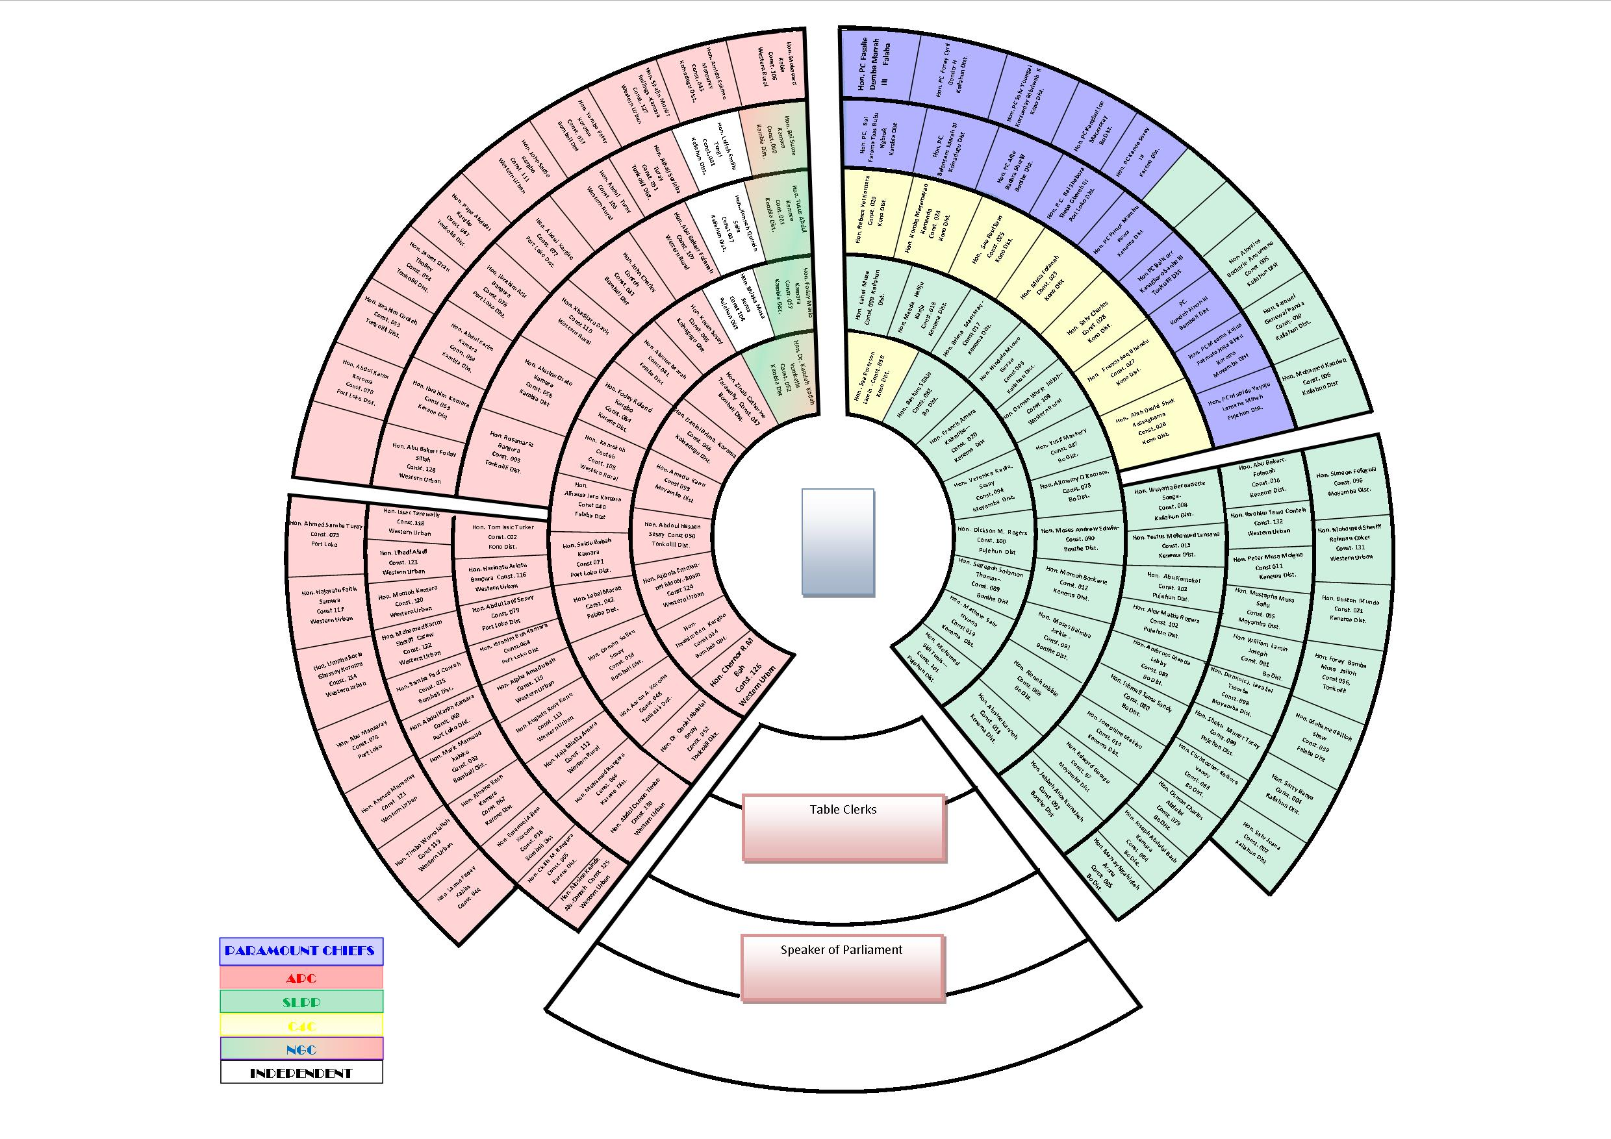

Supported by:

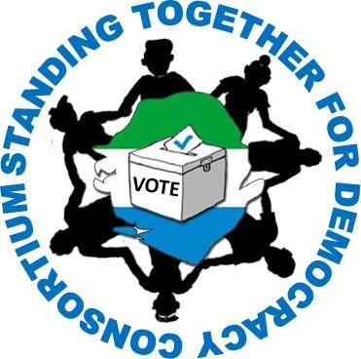


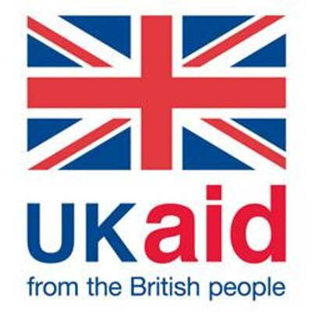

Written by:
Pst. Joseph Conteh (ICT Manager)

Contributors
Mr. Mohamed Lebbie
Mr. Cyril Juxon Smith
Mr. Peter J. Kulagbanda
Mr. Sheku Lamin Turay
Mr. Mohamed Jalloh (WFD Country Representative Sierra Leone)
Lakshmi Pillai (UNDP Chief Technical Advisor)
Rama Musa (Reporter for Tablet Magazine)
Charlotte Ergan (WFD Programme Manager Africa)

References:
Inter Parliamentary Union
Wikipedia-online Encyclopedia
Elections Today
African Elections Database
Tablet Magazine

.

